

**END OF TERM ONE EXAMINATIONS 2023**

**TOP CLASS**

**LANGUAGE DEVELOPMENT TWO**

NAME_______________________________

1. **What is the weather like**?

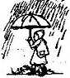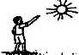



It is



It is

1. **Read and draw dangers**

|  |  |  |  |
| --- | --- | --- | --- |
| fire | knife | broken glass | needle |
|  |  |  |  |

1. Name these

|  |  |  |  |
| --- | --- | --- | --- |
|  |  |  |  |
|  |  |  |  |

1. **Write the words correctly**.

usn

nabana

ainr

1. What do you do everyday?



Sweep, wash, read, play, write)



Everyday, I my book.

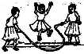



Everyday, I in my book.



Everyday, we .





Everyday, I my classroom.

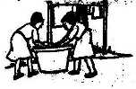



We our uniforms every day.

1. **Do you like ………?**



I like ……../ I don’t like...



I like



I like



I like

1. 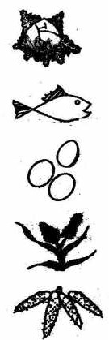**Read and draw**



I don’t like



I don’t like

|  |  |  |
| --- | --- | --- |
| She is cooking. | He is reading a book. | They are playing |
| The ball is on the table. | The cat is under the chair. | The bird is flying over the house. |

1. **Use: Yes, they are/No, they are not.**

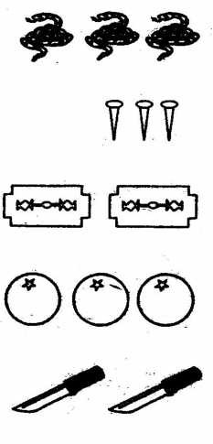

Are these goats?

Are these pins?

Are these razorblades?

Are these eggs?

Are these shoes?

1. **Fill in the missing letters.**

m lk m ngo bea s carr t

doct r b dge lag